MAJOR CLIMATIC ZONES OF THE WORLD

Learning objectives:

* By the end of this lesson
* , you will be able to;
* Understand the term climate.
* Know the names of the major climatic regions of the world.
* Be able to understand the main characteristics of the climate, factors affecting these characteristics and how each climate affects the vegetation of the area.
* Understand how peoples ways of life are influenced by the climate in each region
* Plot major climatic regions on a world map.
* Recognize each type of climateregion on photographs
* Be able to plote each climate on a graph.

Describing the climate of our local areas

Study the photographs in figure 11.1 below and do the tasks that follow.

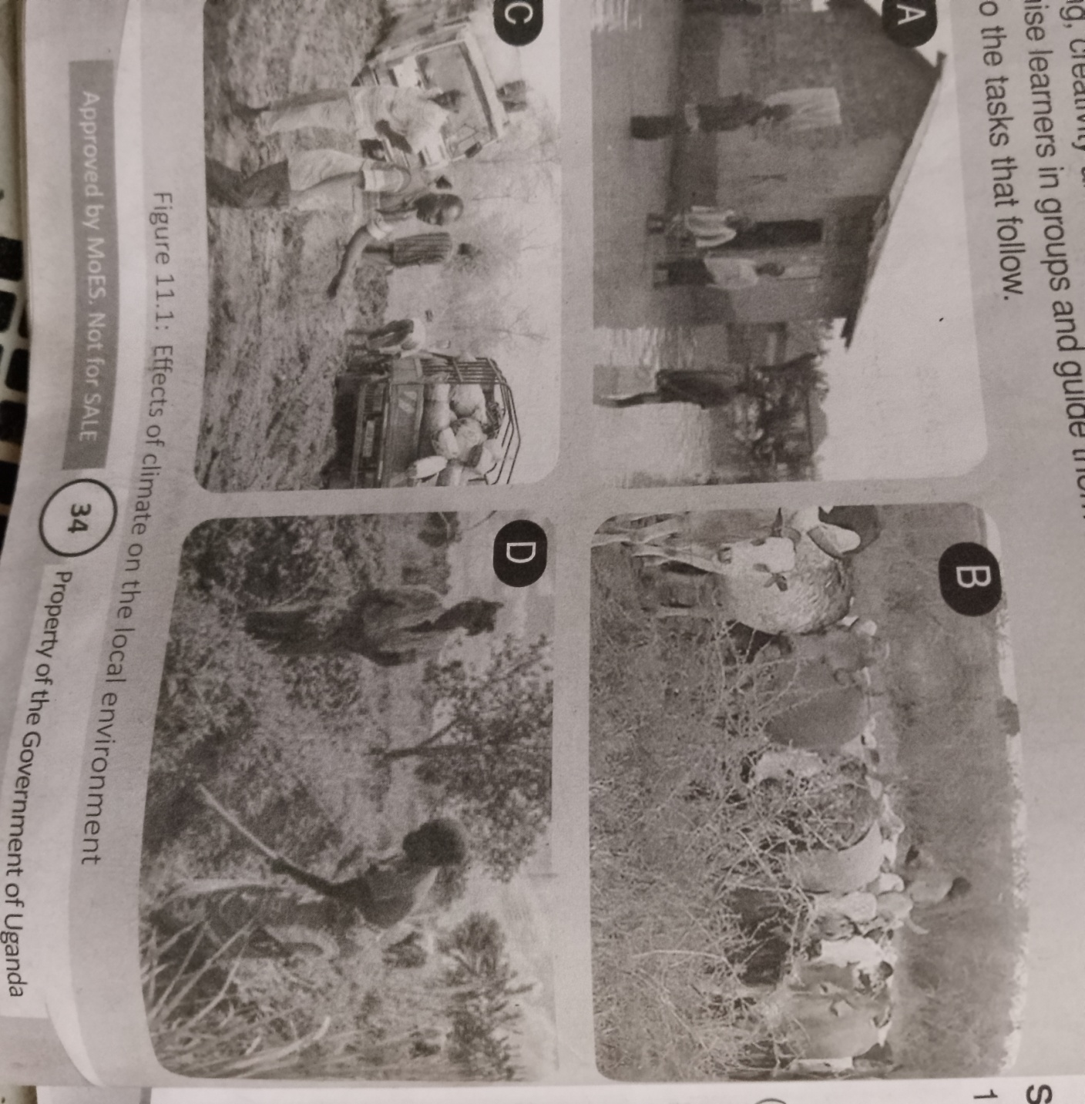

1. Explain what is taking place in each photogragh.

(b) suggest areas in east Africa where these photographs could have been taken.

2. explain the weather conditions responsible what you see in photographs A-D.

3.Why is it important for the people in the photograph to know the climatic conditions of their local area.

4. what type of climate do you usuallyexperience in your home area?

(b) explain what brings about that type of climate.

5- define the term climate?

Factors affecting climate.

Several factors influence climate. These factors can be broadly categorized into natural and human-induced factors. Here are some of the key factors affecting climate:

1 **Latitude**. Places located at high latitudes (far from the equator) receives less sunlight than places at low latitudes (close to equator)

2. **Relief:** climate can be affected by mountains . mountains receive more rainfall than low lying areas because as air is forced over the higher ground it cools, causing moist air to condense and fall out as rainfall,

3. **Distance from water bodies**, the water body affects the climate of a place coastal areas are cooler and wetter than inland areas. Clouds form when warm air from inland areas meets cool air from the water body

4**. Directrion of winds**. Winds that blow from the water bodies often bring rain to the coast and dry weather to the inland areas prevailing.winds that blow to Britain from warm inland areas such as Africa will be warm and dry.

5. **Distance from the equator.** The distance from the equator affects the climate of a place .At the poles. Energy from the sun reaches the earths surface at lower angles and passes through a thicker layer of atmosphere than at the equator.

**6.Solar Radiation**: The amount of solar radiation received by the Earth varies depending on factors such as the Earth's orbit, tilt, and the distance from the sun. This solar energy drives the Earth's climate system.

**7,Atmospheric Composition**: The composition of the Earth's atmosphere, including gases such as carbon dioxide (CO2), methane (CH4), water vapor, and aerosols, affects the greenhouse effect and thus influences climate. Greenhouse gases trap heat in the atmosphere, leading to warming.

**8.Ocean Currents**: Ocean currents play a crucial role in regulating climate by redistributing heat around the globe. Warm ocean currents transfer heat from the equator towards the poles, while cold currents bring cooler water from the poles towards the equator, influencing regional climates.

**9.Land and Water Distribution**: The distribution of landmasses and oceans affects climate patterns. Land heats up and cools down more quickly than water, leading to temperature variations between land and sea. Coastal areas often experience milder climates due to the moderating influence of nearby oceans.

**10. Topography**: The shape and elevation of the land, such as mountains, valleys, and plains, influence local climate patterns. Mountains can block prevailing winds and affect precipitation patterns, leading to variations in climate on either side (rain shadow effect).

**11. Albedo**: Albedo refers to the reflectivity of the Earth's surface. Surfaces with high albedo, such as ice and snow, reflect more solar radiation, while surfaces with low albedo, like dark forests and urban areas, absorb more solar radiation, leading to warming.

**12. Human Activities**: Human activities, such as burning fossil fuels, deforestation, agriculture, and urbanization, release greenhouse gases and aerosols into the atmosphere, leading to changes in climate. These activities contribute to global warming and climate change.

**13. Natural Events**: Natural events such as volcanic eruptions and solar cycles can also influence climate. Volcanic eruptions release sulfur dioxide and ash into the atmosphere, which can temporarily cool the climate by blocking sunlight. Solar cycles, which involve fluctuations in solar activity, can affect solar radiation reaching the Earth.

Major world climatic zones

The major climatic zones of the world, based on their distance from the equator, can be broadly categorized into the following:

1. **Tropical Zone (Equatorial Zone)**:
   * Located near the equator, between the Tropic of Cancer and the Tropic of Capricorn (approximately 23.5 degrees north and south latitudes).
   * Characterized by high temperatures throughout the year due to the direct angle of the sun's rays.
   * Typically experiences little seasonal variation in temperature.
   * High humidity and abundant rainfall, resulting in lush tropical rainforests.
   * Examples include the Amazon Rainforest in South America and the Congo Basin in Africa.
2. **Subtropical Zone**:
   * Extends from approximately 23.5 to 35 degrees north and south latitudes.
   * Characterized by warm to hot temperatures and relatively low precipitation.
   * May experience distinct wet and dry seasons.
   * Vegetation includes savannas, scrublands, and desert regions.
   * Examples include the Sahara Desert in Africa and the Sonoran Desert in North America.
3. **Temperate Zone**:
   * Extends from approximately 35 to 66.5 degrees north and south latitudes.
   * Characterized by moderate temperatures and distinct seasonal variations.
   * Typically has four seasons: spring, summer, autumn (fall), and winter.
   * Precipitation can vary, with regions ranging from wet to dry climates.
   * Vegetation includes deciduous and coniferous forests, grasslands, and mixed ecosystems.
   * Examples include the temperate forests of North America, Europe, and East Asia.
4. **Polar Zone**:
   * Located near the poles, extending from approximately 66.5 degrees north and south latitudes to the respective poles.
   * Characterized by cold temperatures, especially in winter when polar regions experience continuous darkness.
   * Extreme seasonal variations, with long daylight hours in summer and extended periods of darkness in winter.
   * Low precipitation, mostly in the form of snow.
   * Vegetation is limited to tundra and ice-covered landscapes.
   * Examples include the Arctic and Antarctic regions.
5. **Desert**. most desert lie between 150 and 350 north and south of the equator.they were created by air that rises over the equator and comes down over the tropic of cancer and the tropic of Capricorn.
6. **Savannah climate zones** are mostly located between the equator and the the tropics . the largest savanna is located in Africa . nearly half of the continent of Africa is covered with savanna grassland;

These climatic zones are influenced by factors such as latitude, proximity to oceans, prevailing wind patterns, and topography. Understanding these zones helps in predicting weather patterns, studying ecosystems, and planning human activities such as agriculture and urban development.

Top of Form

Characteristics of the major world climatic zones.

Here are the characteristics of the major world climatic zones:

1. **Tropical Zone (Equatorial Zone)**:
   * High temperatures year-round due to the direct angle of the sun's rays.
   * Little seasonal temperature variation.
   * High humidity and abundant rainfall, leading to lush tropical rainforests.
   * Dense vegetation with a diverse range of plant and animal species.
   * Examples include the Amazon Rainforest in South America and the Congo Basin in Africa.
2. **Subtropical Zone**:
   * Warm to hot temperatures with relatively low precipitation.
   * May experience distinct wet and dry seasons.
   * Vegetation includes savannas, scrublands, and desert regions.
   * Presence of hot desert climates with little vegetation and cold desert climates with sparse vegetation.
   * Examples include the Sahara Desert in Africa and the Sonoran Desert in North America.
3. **Temperate Zone**:
   * Moderate temperatures with distinct seasonal variations.
   * Typically experiences four seasons: spring, summer, autumn (fall), and winter.
   * Precipitation varies, ranging from wet to dry climates.
   * Vegetation includes deciduous and coniferous forests, grasslands, and mixed ecosystems.
   * Examples include temperate forests in North America, Europe, and East Asia.
4. **Polar Zone**:
   * Extreme cold temperatures, especially in winter, with continuous darkness in polar regions.
   * Extreme seasonal variations, with long daylight hours in summer and extended periods of darkness in winter.
   * Low precipitation, mainly in the form of snow.
   * Limited vegetation, mainly tundra vegetation adapted to cold and harsh conditions.
   * Examples include the Arctic region surrounding the North Pole and the Antarctic region surrounding the South Pole.
5. **Savannah**

Savannah climate, also known as tropical savanna climate, is typically found in regions situated between tropical rainforests and arid deserts. Here are the characteristics of savannah climate:

* **Temperature**: Savannah climates are characterized by warm to hot temperatures throughout the year. However, there are noticeable seasonal variations in temperature. Daytime temperatures can be high, often reaching or exceeding 30°C (86°F) during the hottest months.
* **Seasonal Variation**: Savannah climates experience distinct wet and dry seasons. During the wet season, which typically occurs in the summer months, there is heavy rainfall. The dry season, often in the winter months, is characterized by little to no rainfall.
* **Rainfall**: Rainfall in savannah climates is seasonal and unevenly distributed. The wet season brings significant rainfall, which sustains vegetation growth, while the dry season is marked by drought conditions. Annual precipitation ranges from 500 to 1,500 millimeters (20 to 59 inches).
* **Vegetation**: Savannah regions are characterized by a mix of grasslands and scattered trees, such as acacias and baobabs. The vegetation is adapted to survive both the dry and wet seasons. Grasses dominate the landscape and provide grazing grounds for herbivores.
* **Wildlife**: Savannah climates support diverse wildlife, including large herbivores like zebras, giraffes, and elephants, as well as predators like lions, leopards, and cheetahs. The availability of water and vegetation during the wet season attracts migratory animals.
* **Fires**: Fires are a natural part of the savannah ecosystem. They occur during the dry season and play a crucial role in maintaining the balance of vegetation and preventing the encroachment of forests into grasslands.
* **Human Settlements**: Human populations in savannah regions often engage in agriculture and pastoralism. They rely on the seasonal rainfall patterns for crop cultivation and livestock grazing.
* Savannah climates are found in regions such as parts of Africa, South America, Australia, and India. Understanding the characteristics of savannah climate is essential for managing natural resources, wildlife conservation, and sustainable development in these regions.

Top of Form

These characteristics are influenced by factors such as latitude, proximity to oceans, prevailing wind patterns, and topography. Understanding the characteristics of these climatic zones is essential for various purposes, including agriculture, ecology, and urban planning.

1. **Deserts**

Desert climates are characterized by extreme aridity and wide temperature variations between day and night. Here are the key characteristics of desert climates:

* **Low Precipitation**: Deserts receive very little rainfall, often less than 250 millimeters (10 inches) annually. Some deserts may experience years without any significant rainfall. This low precipitation is insufficient to support extensive vegetation growth.
* **High Temperatures**: Deserts are known for their high daytime temperatures. During the day, temperatures can soar above 40°C (104°F) or even higher, depending on the season and location. However, despite the high daytime temperatures, nights can be surprisingly cold due to the lack of moisture in the air, leading to rapid heat loss.
* **Wide Temperature Variations**: Desert climates exhibit wide temperature variations between day and night. While daytime temperatures are often scorching hot, nighttime temperatures can drop significantly, sometimes below freezing, due to the lack of cloud cover and insulation.
* **Low Humidity**: Desert climates are characterized by low humidity levels. The air in deserts is typically dry, with low moisture content. This low humidity contributes to the extreme aridity of the environment and accentuates the feeling of heat during the day and cold at night.
* **Sparse Vegetation**: Vegetation in deserts is limited and adapted to survive in arid conditions. Plants in deserts often have specialized adaptations, such as deep root systems, succulent leaves, and water-storing tissues, to cope with the limited water availability. Cacti, succulents, and drought-resistant shrubs are common in desert landscapes.
* **Sand Dunes and Rock Formations**: Deserts often feature distinctive landforms such as sand dunes, rocky outcrops, and mesas. Wind erosion and weathering shape these landforms over time, creating visually stunning landscapes.
* **Animal Adaptations**: Desert animals have evolved various adaptations to survive in harsh desert conditions. Some common adaptations include nocturnal behavior to avoid the heat, efficient water conservation mechanisms, and specialized physiological adaptations to cope with extreme temperatures.
* **Human Settlements**: Despite the harsh conditions, some desert regions support human populations. Traditional desert dwellers often rely on nomadic or semi-nomadic lifestyles, herding livestock and practicing subsistence agriculture in oases or areas with access to water sources.

Desert climates are found on every continent and cover approximately one-third of the Earth's land surface. Understanding the characteristics of desert climates is crucial for conservation efforts, resource management, and sustainable development in these regions.

**THE INLUENCE OF CLIMATE ON VEGETATION.**

**Top of Form**

Climate has a profound influence on vegetation, shaping the distribution, composition, and structure of plant communities around the world. Here's how climate influences vegetation:

1. **Temperature**: Temperature affects the growth and distribution of vegetation by influencing the rate of photosynthesis, metabolism, and plant respiration. Different plant species have specific temperature ranges within which they can thrive. For example, tropical rainforests are found in regions with warm temperatures year-round, while tundra vegetation is adapted to cold climates.
2. **Precipitation**: Precipitation is a critical factor determining the presence and density of vegetation. Plants require water for photosynthesis, growth, and reproduction. Areas with high rainfall support lush vegetation, such as forests and wetlands, while regions with low precipitation, like deserts, have sparse vegetation adapted to arid conditions.
3. **Seasonality**: Seasonal changes in temperature and precipitation influence plant phenology, including flowering, leafing, and fruiting. Deciduous trees shed their leaves in response to changes in temperature and daylight hours, while evergreen trees maintain their foliage year-round. Seasonal rainfall patterns also affect the timing of plant growth and flowering.
4. **Water Availability**: Besides precipitation, factors such as soil moisture, groundwater levels, and humidity influence water availability for plant growth. Plants in water-stressed environments develop adaptations such as deep root systems, succulent tissues, and drought tolerance mechanisms to survive in arid conditions.
5. **Sunlight**: Sunlight is essential for photosynthesis, the process by which plants convert light energy into chemical energy. Light availability varies with latitude, altitude, and topography, influencing the distribution of vegetation types. For example, forests are prevalent in areas with ample sunlight, while shade-tolerant plants thrive in the understory of dense forests.
6. **Wind**: Wind patterns affect vegetation by dispersing seeds, pollen, and propagules, shaping plant distribution and genetic diversity. Wind exposure can also influence plant morphology, leading to adaptations such as reduced leaf size and wind-resistant structures in windy environments.
7. **Topography**: Topographic features such as mountains, valleys, and slopes influence microclimates, creating variations in temperature, precipitation, and sunlight exposure. These microclimatic conditions support diverse vegetation communities adapted to different ecological niches, such as montane forests, alpine meadows, and riparian habitats.
8. **Climate Change**: Climate change, driven by human activities, is altering temperature and precipitation patterns worldwide, leading to shifts in vegetation distribution, phenology, and composition. Species may migrate to higher latitudes or elevations in response to changing climatic conditions, affecting ecosystem dynamics and biodiversity.

Understanding the complex interactions between climate and vegetation is crucial for ecosystem management, conservation efforts, and adaptation strategies in the face of climate change.

**INFLUENCE OF CLIMATE ON PEOPLE’S WAY OF LIFE**

Climate exerts a significant influence on people's way of life in various ways, impacting everything from livelihoods to cultural practices. Here are several ways in which climate influences people's way of life:

* **Agriculture and Food Security**: Climate directly affects agricultural productivity by influencing temperature, rainfall patterns, and the frequency of extreme weather events like droughts and floods. Farmers rely on predictable climatic conditions for planting, growing, and harvesting crops. Changes in climate can lead to crop failures, food shortages, and disruptions in supply chains, affecting food security for communities and nations.
* **Water Resources**: Climate determines the availability and distribution of freshwater resources, including rivers, lakes, and groundwater. Variations in precipitation patterns and melting snowpacks affect water availability for drinking, irrigation, and industrial purposes. Droughts and water scarcity can lead to conflicts over water resources and the displacement of communities.
* **Health and Well-being**: Climate influences public health through its impacts on the spread of vector-borne diseases, heat-related illnesses, and extreme weather events. Warmer temperatures can expand the habitat of disease vectors like mosquitoes, increasing the transmission of diseases such as malaria, dengue fever, and Zika virus. Heatwaves and extreme weather events pose risks to vulnerable populations, including the elderly, children, and those with pre-existing health conditions.
* **Livelihoods and Economic Activities**: Many livelihoods and economic activities are closely tied to climate-sensitive sectors such as agriculture, fisheries, forestry, and tourism. Climate variability and change can disrupt livelihoods, undermine economic stability, and exacerbate poverty, particularly in rural and coastal communities dependent on natural resources.
* **Migration and Displacement**: Climate-related events such as hurricanes, floods, droughts, and sea-level rise can force people to migrate from affected areas in search of safer living conditions and opportunities. Climate-induced displacement may lead to social tensions, conflicts, and challenges for host communities and receiving countries.
* **Cultural Practices and Traditional Knowledge**: Climate shapes cultural practices, traditions, and indigenous knowledge systems related to agriculture, land management, resource conservation, and spiritual beliefs. Indigenous peoples and local communities have developed adaptive strategies and resilience mechanisms based on their understanding of the local environment and climate variability.
* **Infrastructure and Urban Planning**: Climate considerations are essential for infrastructure development, urban planning, and disaster risk reduction. Climate-resilient infrastructure and sustainable urban design can help mitigate the impacts of climate-related hazards such as storms, flooding, and heatwaves, enhancing the resilience of communities and cities to climate change.
* **Policy and Governance**: Climate influences policy decisions and governance arrangements at local, national, and international levels. Governments, businesses, and civil society organizations develop policies and strategies to address climate change, mitigate greenhouse gas emissions, and adapt to its impacts, aiming to safeguard the well-being and prosperity of present and future generations.
* Overall, climate plays a fundamental role in shaping people's way of life, highlighting the importance of climate adaptation, resilience-building, and sustainable development efforts to address the challenges posed by climate variability and change.
* Top of Form
* Top of Form
* Top of Form

HAMONIZED BY TR SUNDAY.